

Laboratory Report

Course ID: CPS 2390
Lab 3: Problem Solving with the LC-3

Student: Thomas Yamakaitis

Instructor: Dr. Jing-Chiou Liou

Date: 11/15/2016
Description
The objective of this lab was to create a program in LC-3 that could take the input of two numbers and either divide them or multiply them.
Procedure and Notes
- The test data I used will be provided in the screenshots as well as the results.
- The only difficulty I had with this lab was trying to figure out the algorithm for the division part.
Results and Reports
----------------------------------------------------------------
Lab 3 – Multiplication
----------------------------------------------------------------
.ORIG x3000
AND R0, R0, #0 ;Y
LDI R1, A
LDI R2, B
ADD R1, R1, #0
BRnz END1
ADD R2, R2, #0
BRnz END2
LOOP ADD R0, R0, R1
ADD R2, R2 #-1
BRp LOOP
STI R0, Y

END1 ADD R1, R1, #0
END2 ADD R2, R2, #0
HALT

A .FILL x3100
B .FILL x3101
Y .FILL x3102
.END
----------------------------------------------------------------

----------------------------------------------------------------
Lab 3a – Division
----------------------------------------------------------------
.ORIG x3000
AND R0, R0, #0 ;Z
LDI R1, A
ADD R1, R1, #0
BRnz END1
LDI R2, B
ADD R2, R2, #0
BRnz END2
NOT R2, R2
ADD R2, R2, #1
LOOP ADD R0, R0, #1
ADD R1, R1, R2
ADD R3, R1, R2
BRzp LOOP
STI R0, Z
STI R1, R
END1 ADD R0, R0, #0
END2 ADD R0, R0, #0
HALT

A .FILL x3100
B .FILL x3101
Z .FILL x3103
R .FILL x3104
.END
----------------------------------------------------------------

Lab3 - Multiplication

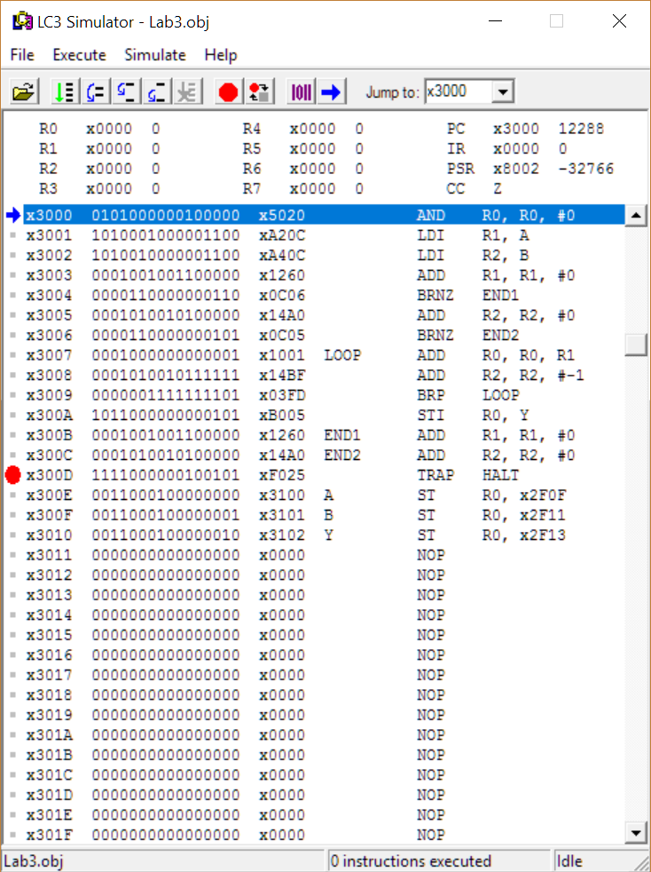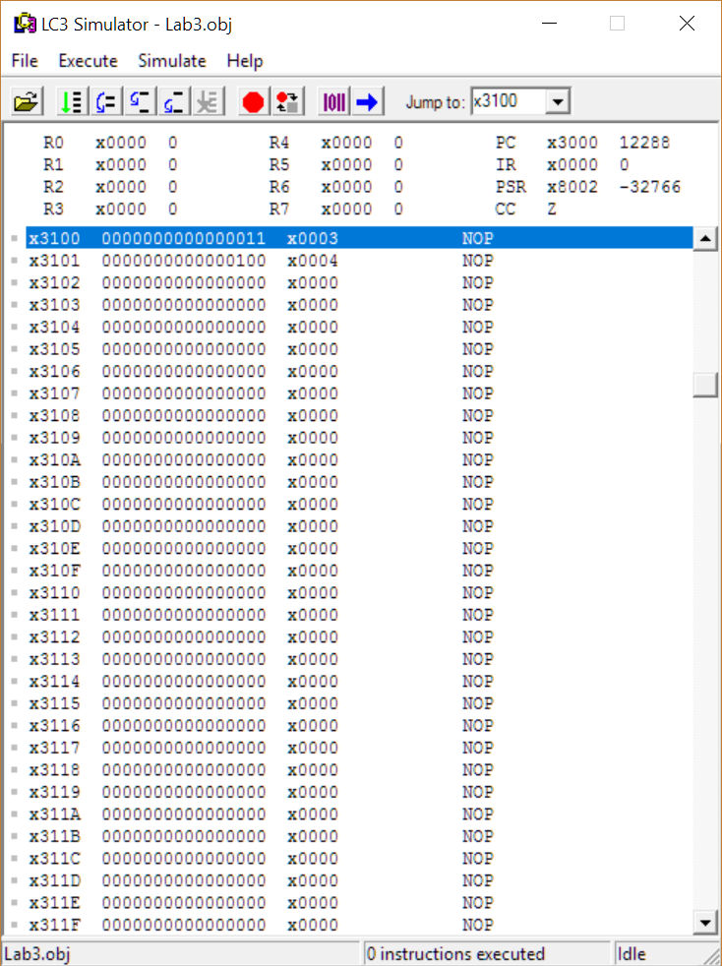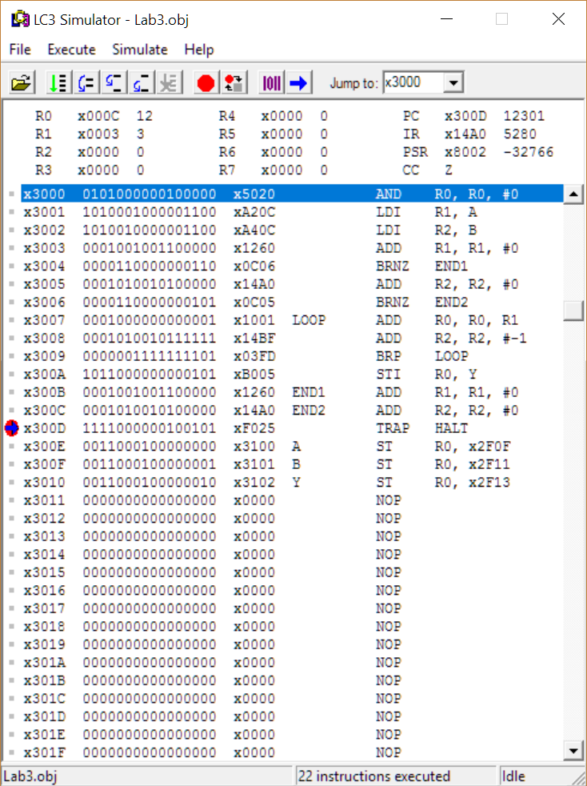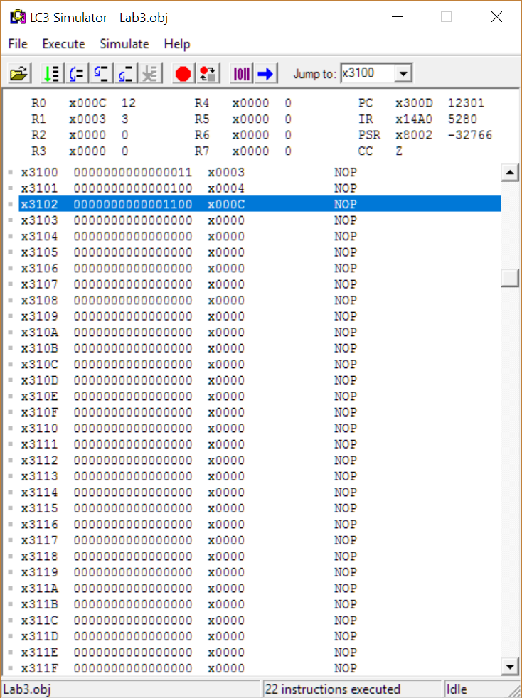
Lab3a – Division
